# **Name: Abdurrahman Qureshi**

# **Roll No: 242466**

Practical No: 9

Date Of Performance: 06/09/2025

Aim: To understand containerization by deploying a lightweight Nginx web server using Docker on an EC2 instance, demonstrating the practical advantages of containers over traditional virtual machines.

1. What is Containerization / Docker? Explain Docker Architecture with the help of diagram
2. Compare Containers vs VMs
3. Why are Containers lightweight?
4. Deploy a containerized web Application on AWS EC2 Linux. [install Docker, pull nginx image and run it]. Pull python images and run the command to list all the locally stored docker images.

 [Terminate the resources after performing the practical- terminate environment and application both]

****ANS.1:****

**Containerization** is a lightweight form of virtualization that packages an application and its dependencies (libraries, config files, etc.) into an isolated, portable unit called a **container**.  
**Docker** is the most popular platform that enables developers to build, ship, and run containers consistently across different environments.

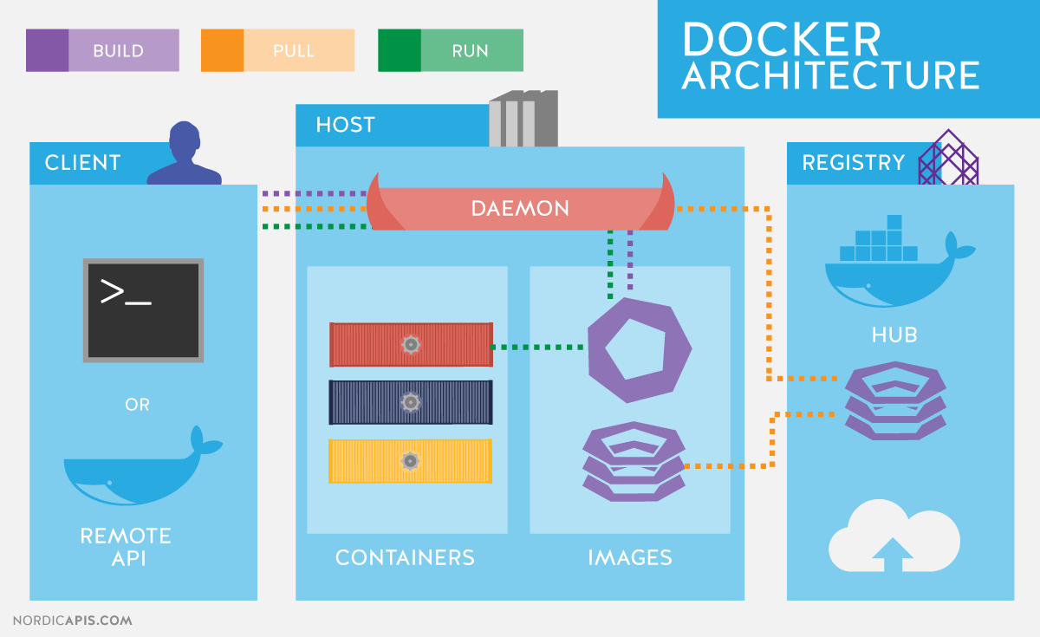

[This Photo](https://devopedia.org/docker) by Unknown Author is licensed under [CC BY-SA](https://creativecommons.org/licenses/by-sa/3.0/)

****ANS.3:****

|  |  |
| --- | --- |
| Containers | Virtual Machines (VMs) |
| Share the host OS kernel | Each VM has its own full OS |
| Lightweight, fast boot-up | Heavy, slower boot-up |
| Less resource overhead | High resource overhead |
| Portable and consistent | Less portable due to size |
| Isolated at process level | Fully isolated hardware virtualization |

****ANS.4:****

Containers are lightweight because they **share the host operating system's kernel** and do not require a full operating system for each instance. Only the application, its dependencies, and a minimal runtime are packaged, eliminating the overhead of multiple guest OSes.